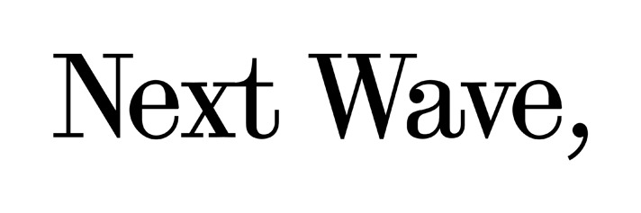
Venue hire scope (i.e. limitations)

Next Wave operates Brunswick Mechanics Institute with the support of Merri-bek City Council. We have a tender agreement that specifies that the venue should be used in a way that:
- Supports artists in the development of work.
- Provides professional development support to artists.
- Demonstrates experimentation and new work supported through programming and curatorial approach.
- Supports local (Merri-bek) based artists.
- Develops partnerships that engage Merri-bek's community.
- Attracts publicity and Media that improves the profile of Brunswick Mechanics Institute.
- Aligns closely with the Merri-bek’s vision for arts and culture and community. Next Wave is committed to fostering civic pride, connection and social cohesion through participation in the arts.

What this means for hirers
This mean that we will occasionally have to decline hires on the basis that they that fall outside of our scope.
This can include seasons of work, the presentation of works that are not undergoing creative development, as well as events that are not arts-related, such as parties, celebrations or launches.
There may also occasionally be hires that fall outside of the capacity of our small team and of our heritage listed venue.
The suitability of hires is determined by and at the discretion of Next Wave, in partnership with Merri-bek City Council.

Reduced-rate hires
Under this agreement, Next Wave can provide venue hire at a reduced rate to support artists/creative practitioners as well as not-for-profits and small-to-medium arts organisations to undertake creative developments and/or deliver community arts initiatives in our space.
We prioritise early career artists/creative practitioners and those who live in Merri-bek, especially those that belong to Merri-bek’s human rights priority groups.

What do we mean by ‘creative development’?
Creative development activities support testing, development and experimentation.
This encompasses rehearsals, workshops, filming, artist talks, work in progress showings, script development, auditions and research—and includes activities that showcase the creative development process.

What do we mean by ‘community arts initiative’?
Community arts initiatives can include small artist-led events/public programs. Next Wave prioritises events/programs that support professional development for and skill exchange between creative practitioners with a focus on emerging practitioners.

Full-rate hires
Our full-rate is for larger organisations and commercial/business activities that are aligned with Next Wave’s values of justice, friendship and care.
Full-rate hires not only help us continue to support early career creative practitioners, they also helps us continue to provide venue hire at a reduced rate (and sometimes in-kind) for those who need it.

View our hire Next Wave Venue Hire Terms and Conditions.
If you have any questions, please contact nextwave@nextwave.org.au

Next Wave’s current agreement extends to June 2024 and will be renewed in July 2025.

