Visual story: Brunswick Mechanics

The during:next (40 year party) is happening at Brunswick Mechanics on 25th May 2024.

Address: 270 Sydney Road, Brunswick, Melbourne

Doors open at 6:00pm.

Face masks, hand sanitiser, ear plugs and sensory kits will be available on the door.

There will be one air purifier in each space.

Next Wave staff will also be there to help.

They will be wearing bright stickers that say: “Next Wave, Staff”.

How to get inside Brunswick Mechanics
Brunswick Mechanics is on the corner of Sydney Road and Glenlyon Road in Brunswick.
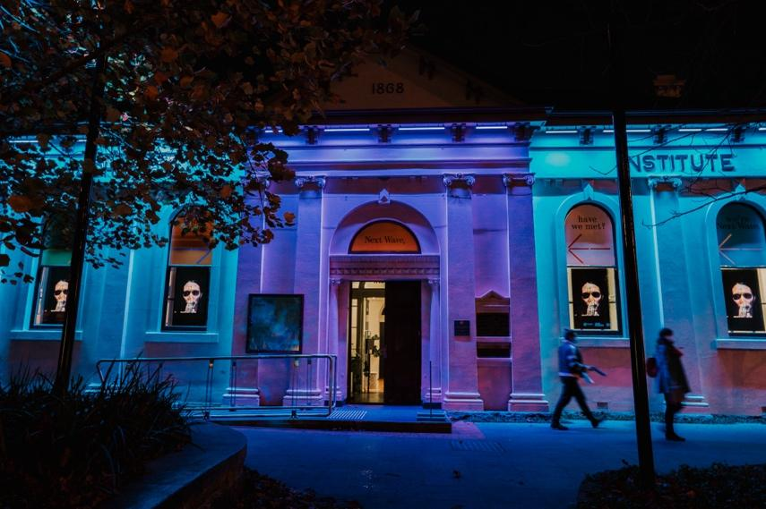 | This is the front of Brunswick Mechanics.  During the day, the building is beige.  At night, it is lit up with bright colours.
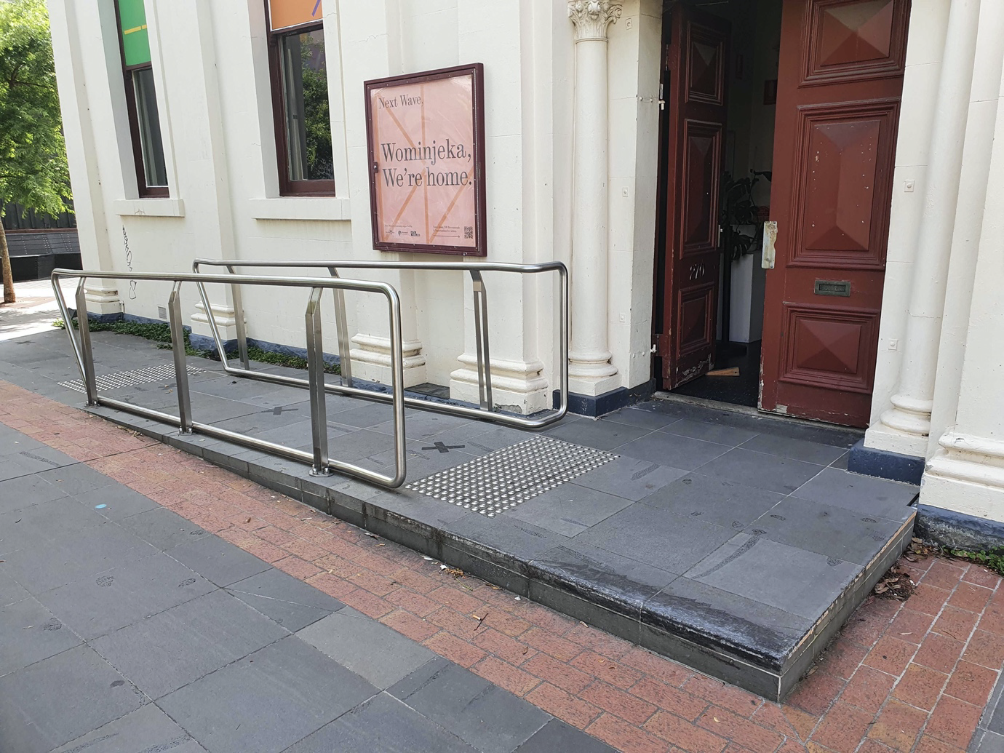 | There is ramp access at the front of the building.  There are handrails on either side of the ramp.
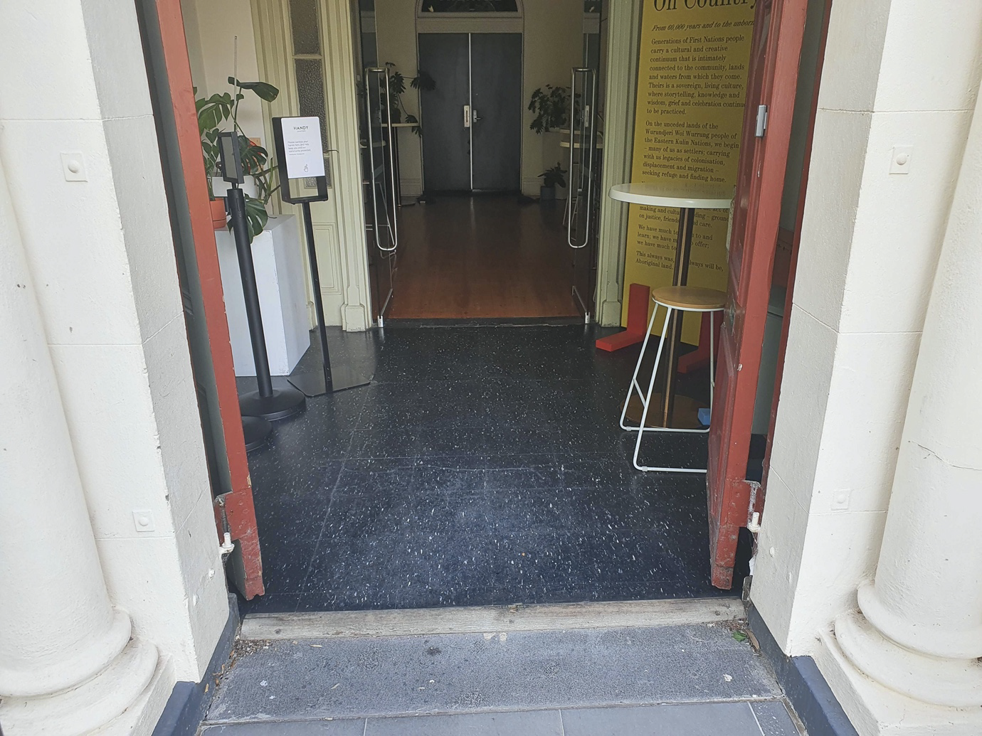 | The front door has a wooden lip.  It is rounded and about 2cm high.
The Foyer
After going through the front door, you will be in the foyer.
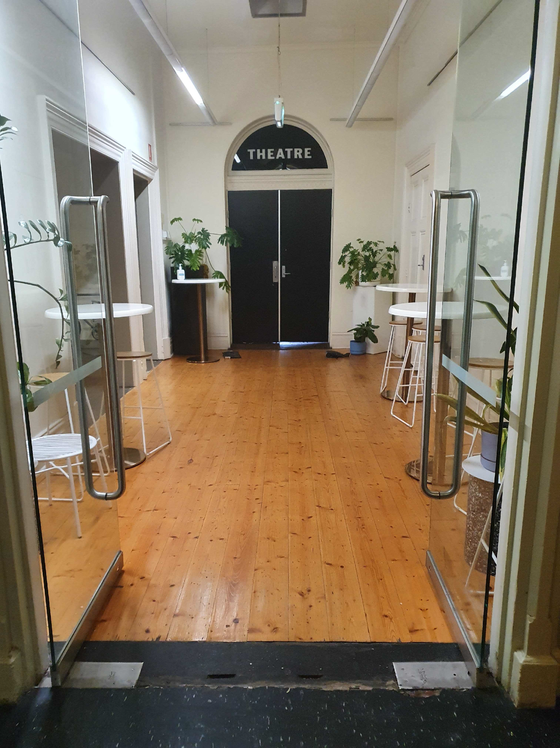 | From the foyer you can access the:  - Theatre  - Bar  - Bathrooms  - Studio space.
The Theatre
During the party, the theatre will have:
- Welcome to Country at 6:15pm
- DJs — Colette, LAKATOI
- Dancing
- Speeches
- Performances — Kudakwashe, NŪ.

A projector will be showing archive images from Next Wave’s past.

There will be old TVs stacked up as props.

The MC will introduce performances and provide information.

Auslan interpreters will be there throughout the party.

Haptic vests can be booked in advance.

Some Haptic vests will also be available on the night.

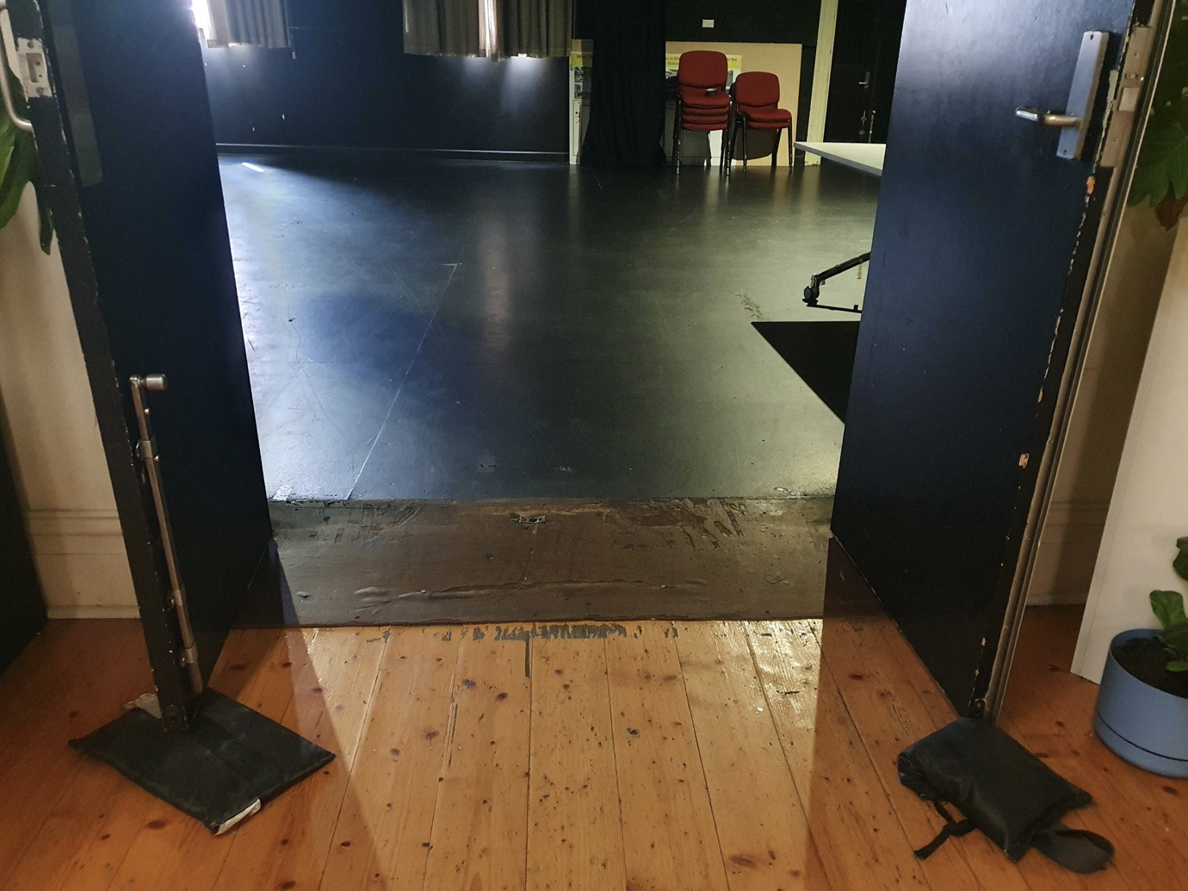 | The double doors leading to the theatre will be open.
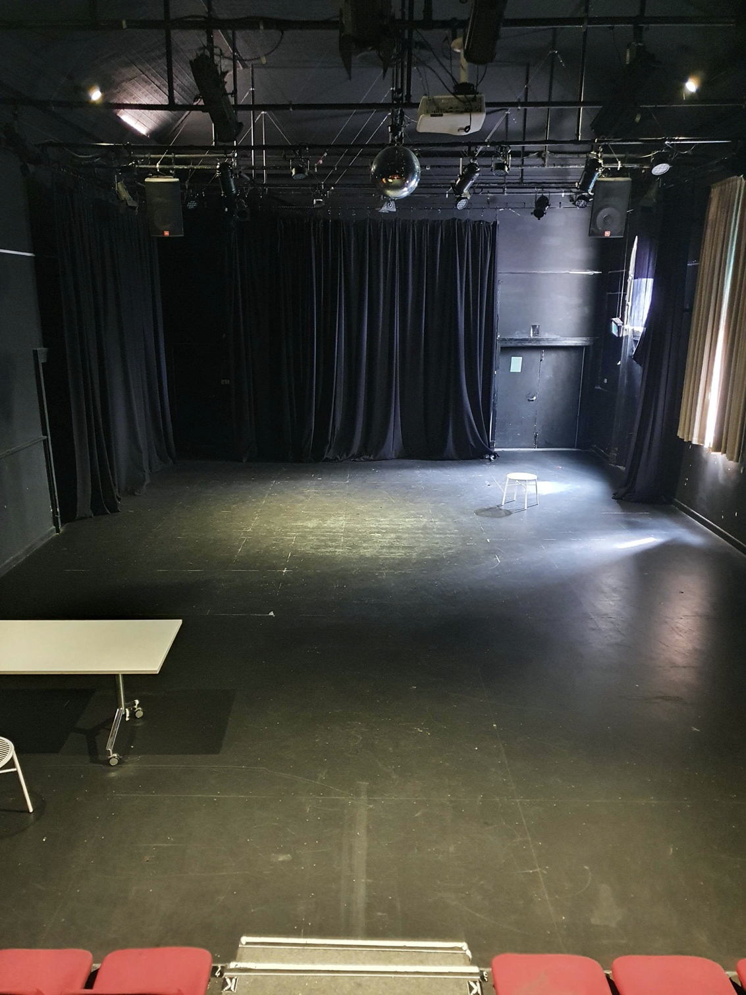 | The theatre is a large space, with drapes hanging from the walls.  During the party, there will be brightly coloured lighting and haze.  There will be no strobe or flashing lights.
The Studio
During the party, the studio will be a chill out space for conversation.

There will be performances from:
- Live Painter — Mukisa
- Live Scribe — Josie

You can share a story with Josie about Next Wave's past or a hope for Next Wave's future.

Your response will form a collaborative drawing across the night.

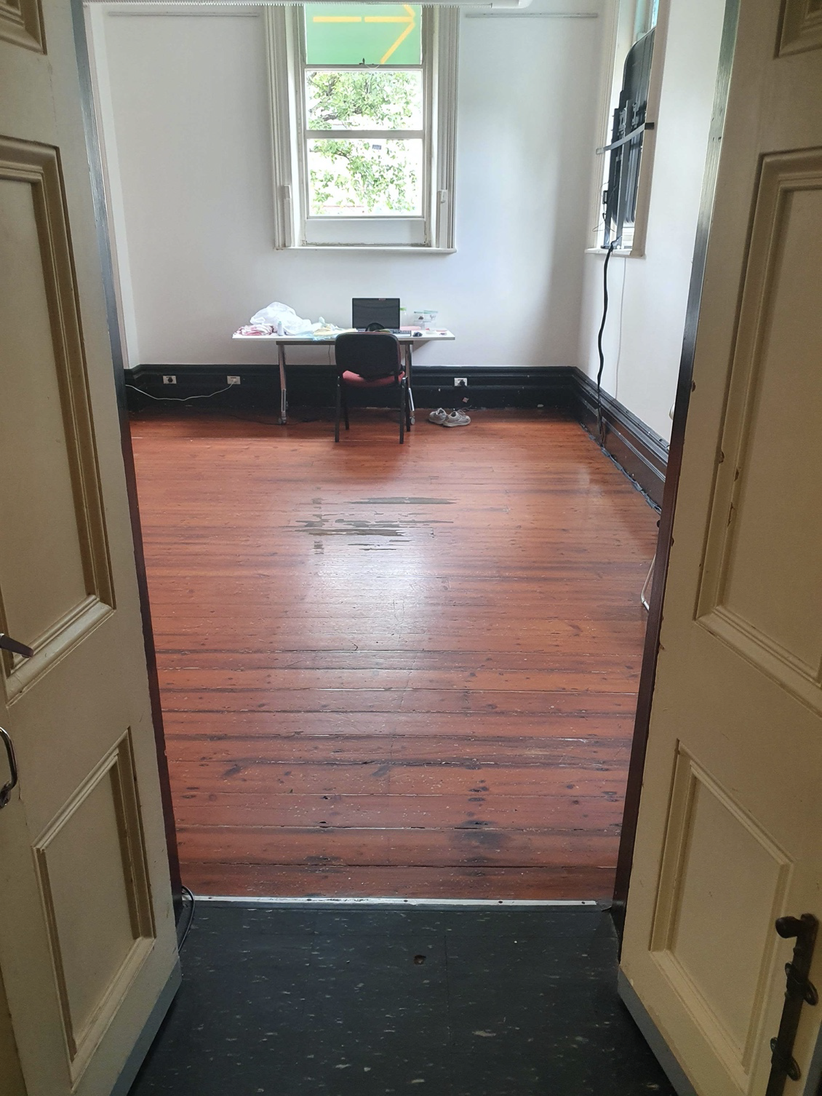 | The studio is located at the front of the building.  From the foyer, you enter the studio through a set of double doors.
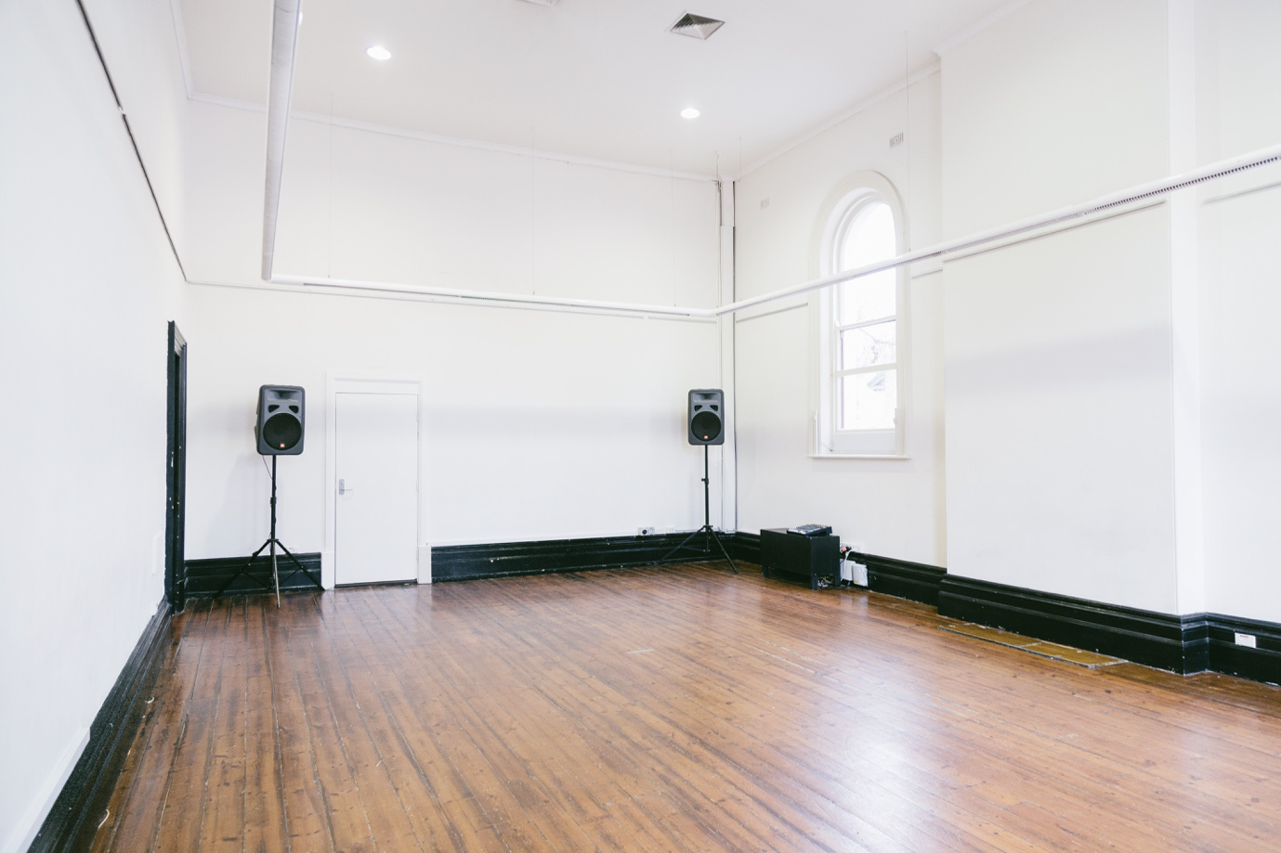 | The studio will have low lighting and soft furnishings.  There will be a sensory space set up in the corner of the studio with fidget toys available.  You are welcome to bring your own fidgets.

Bathrooms
Brunswick Mechanics has gender-neutral bathrooms.
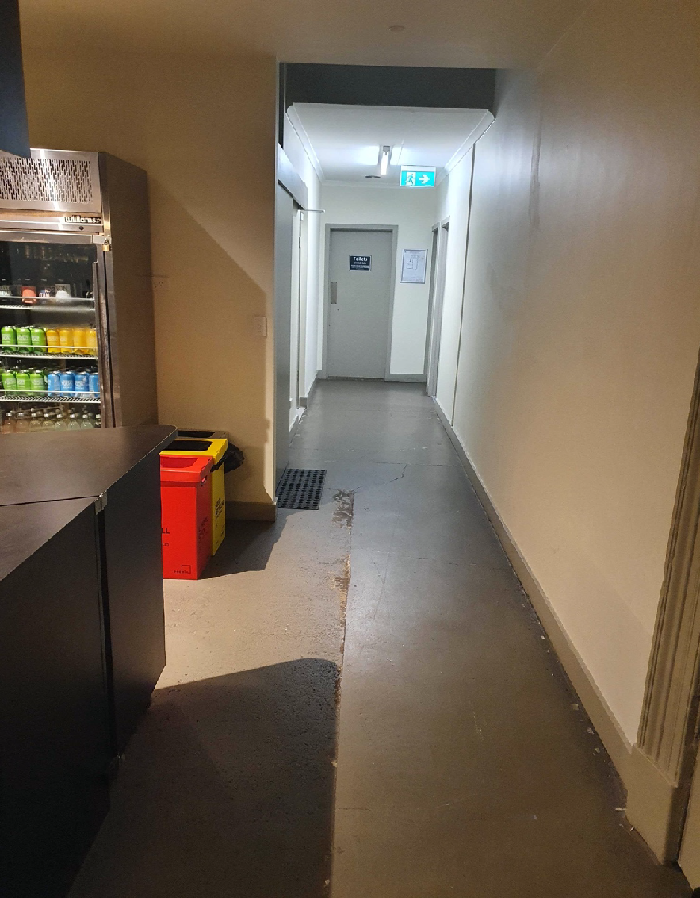 | To access the bathrooms, go past the bar and down the hallway.
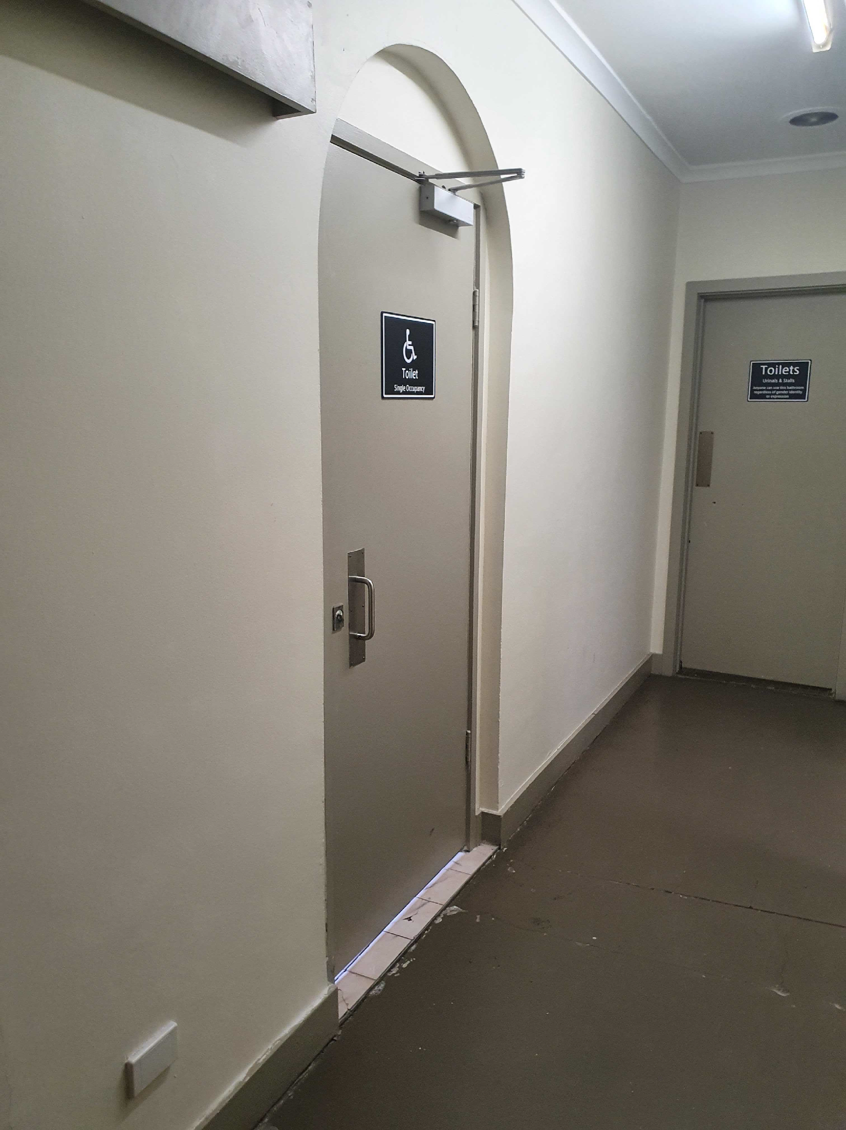 | At the end of the hall, there is a gender-neutral bathroom with stalls and urinals.
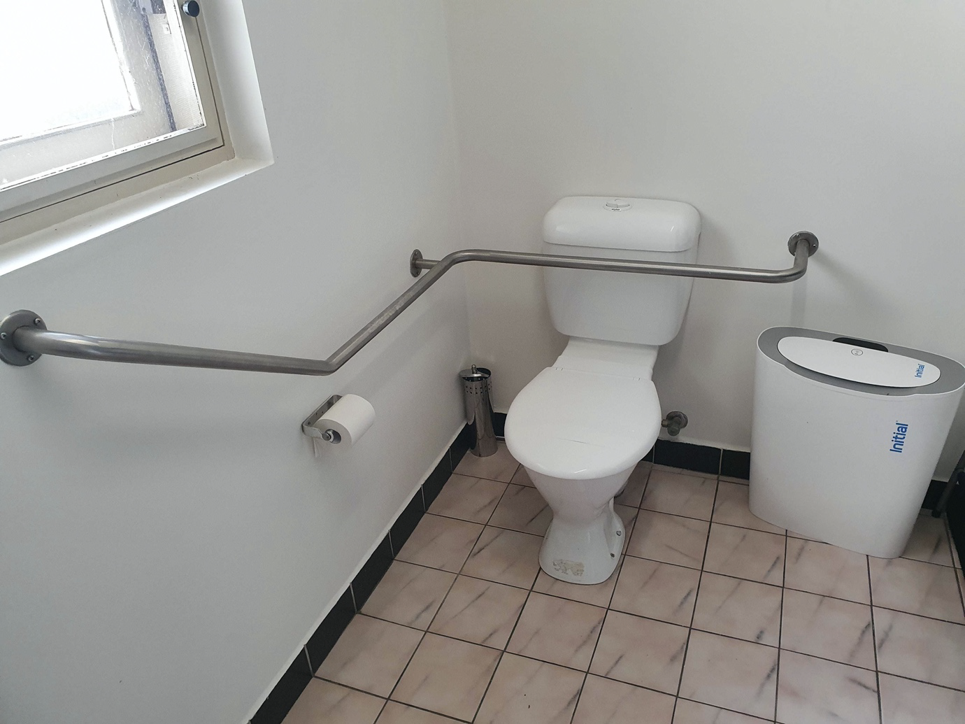 | There is also an accessible bathroom.  It is a large room.  There is a grab rail next to the toilet.

Food and drinks

Prepackaged snacks will be served in the courtyard.

There will be vegetarian options.

The courtyard is outside to the left of the entrance. You can also take the snacks inside to eat.

A big 40 year cake will be served at 9.30pm in the Theatre.

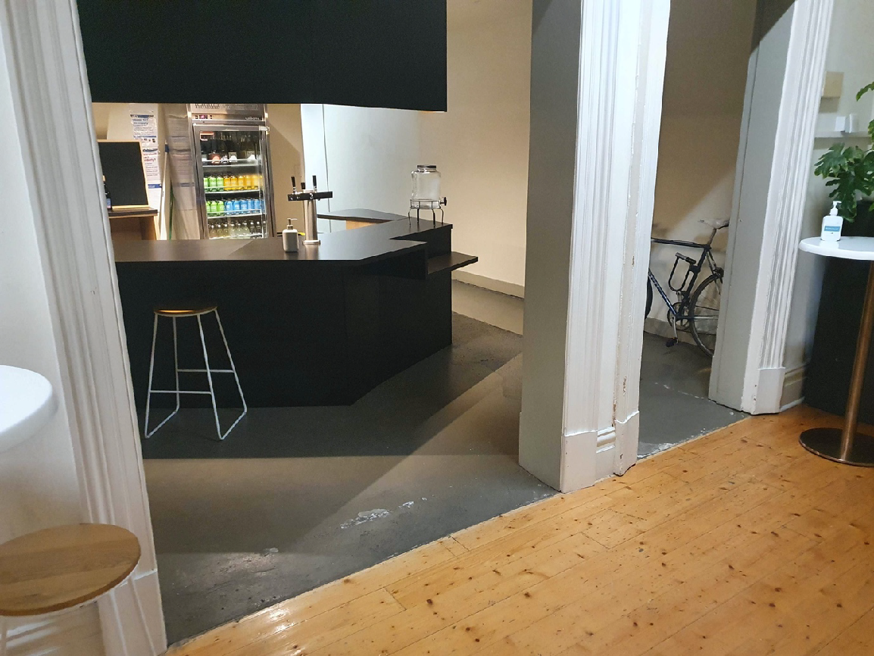 | The bar is in the Foyer.  There will be alcoholic and non-alcoholic drinks available during the party.

Schedule
6:00pm — Doors open

6:15pm — Welcome to Country

6:30pm — Speech 1: the present

6:45pm — Performance 1: NŪ / Dinner service commences

7.30pm — Speech 2: the past

8:00pm — Performance 2: Kudakwashe

8.30pm — DJ set 1: Colette (Vinyl Selector) / Dinner service ends

9:30pm — Speech 3: the future and 40 year Birthday cake served

9:45pm — DJ set 2: LAKATOI (Digital Selector)

11:00pm — Party ends

