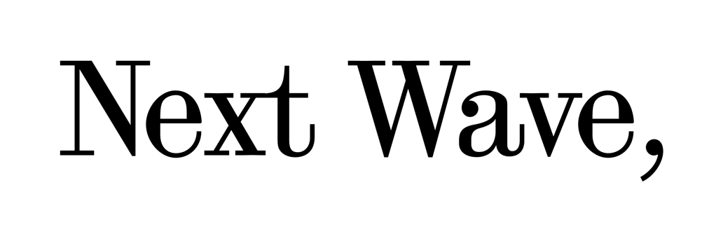

Strategic Plan 2025–2028

About us
Next Wave is a leading not-for-profit arts organisation that, since 1984, has played a pivotal role in supporting early-career practitioners working across multiple art forms. Next Wave creates spaces for connection, experimentation and investment—through mentorship programs, public programs and venue hire—from our homebase at Brunswick Mechanics Institute and across Victoria.

Our vision
A world shaped by artists—where sustainable practices for early-career practitioners are prioritised across the arts and creative industries.

Our purpose
To nurture and resource early-career practitioners through creative development, intergenerational exchange and industry pathways.

Our values and goals

Justice
We commit to:
- Supporting First Nations cultural protocols, self-determination and cultural safety, across all aspects
of our operations and programming.
- Minimising barriers to access and participation for artists, to reflect diverse stories, cultures
and experiences.
- Equitable, ethical and inclusive work conditions.

Friendship
We commit to:
- Fostering possibilities for reciprocal and intergenerational listening, learning and exchange.
- Working with people in ways that are non-extractive and non-appropriative.
- Sharing our skills and resources with an expanding and evolving network of artists, communities, organisations and audiences.

Care
We commit to:
- Creating a culturally safe organisation for people to be who they are.
- Working with our collaborators at a pace that recognises each other’s capacities and capabilities.
- Building purposeful cross-industry partnerships to support sustainable practices.

Our Priorities and Outcomes

Artists
We support early-career practitioners to test, develop and share their creative practice.
We do this by:
- Delivering intergenerational and peer-to-peer mentorship programs
- Recognising early-career as a practitioner in the initial stage of their professional career, rather than age-specific
- Providing space, time and remuneration to practitioners through open and accessible expressions of interest (EOI)
- Focusing on professional and creative development that has flexible programming outcomes, and supports experimentation
- Advocating for mentorship and artist-led learning that is rigorous and sustained
- Prioritising practitioners who endure systemic barriers to access and participation in the industry, including First Nations, migrant and refugee, d/Deaf, Disabled, neurodivergent, chronically ill and LGBTIQA+ communities

Programming
We connect artists, audiences, and communities to learn with and from each other.
We do this by:
- Delivering public-facing and industry-specific events, workshops, artist talks, screenings and presentations that showcase the creative development process
- Presenting accessible and inclusive programs that reflect and engage the diversity of our Merri-bek and Victorian communities
- Establishing Brunswick Mechanics Institute as a space for creation, and prioritising venue hire to Merri-bek artists and communities.
- Honouring the history of Brunswick Mechanics Institute as a space of communal and informal learning, to continue this legacy for a new generation of practitioners.
- Creating a Program Advisory Group to enrich our programming approach.

Community
We create open and welcoming spaces for communities to gather and engage in creative experimentation.
We do this by:
- Responding to community needs through open day neighbourhood gatherings at Brunswick Mechanics Institute and by opening our front doors regularly.
- Activating the external spaces of Brunswick Mechanics Institute to provide multiple points of connection for communities to engage with Next Wave.
- Prioritising communities from Merri-bek and Victoria, and sharing opportunities beyond the inner-city to the suburbs, regions and rural communities.
- Mobilising a Program Advisory Group to ensure that Merri-bek and broader Victorian-based communities see themselves represented and reflected in our program outputs.
- Upholding an organisation-wide commitment to access, diversity, equity and inclusion.

Partnerships
We collaborate with values-aligned organisations to deliver responsive and impactful opportunities for early-career practitioners.
We do this by:
- Sharing our resources, experiences, skills and space with other arts organisations to collectively build the capacity of early-career practitioners.
- Deepening our engagement with Merri-bek and Victoria-based organisations.
- Strengthening our relationships with First Nations, migrant and refugee, d/Deaf, Disabled, neurodivergent, chronically ill and LGBTIQA+ led arts and cultural organisations.
- Divesting from organisations that do not share our values or commitment to sustainable practices.

For more information
Visit nextwave.org.au
Email nextwave@nextwave.org.au

